Which lambda can replace the new Sloth() call in the main()

Interface Yawn…

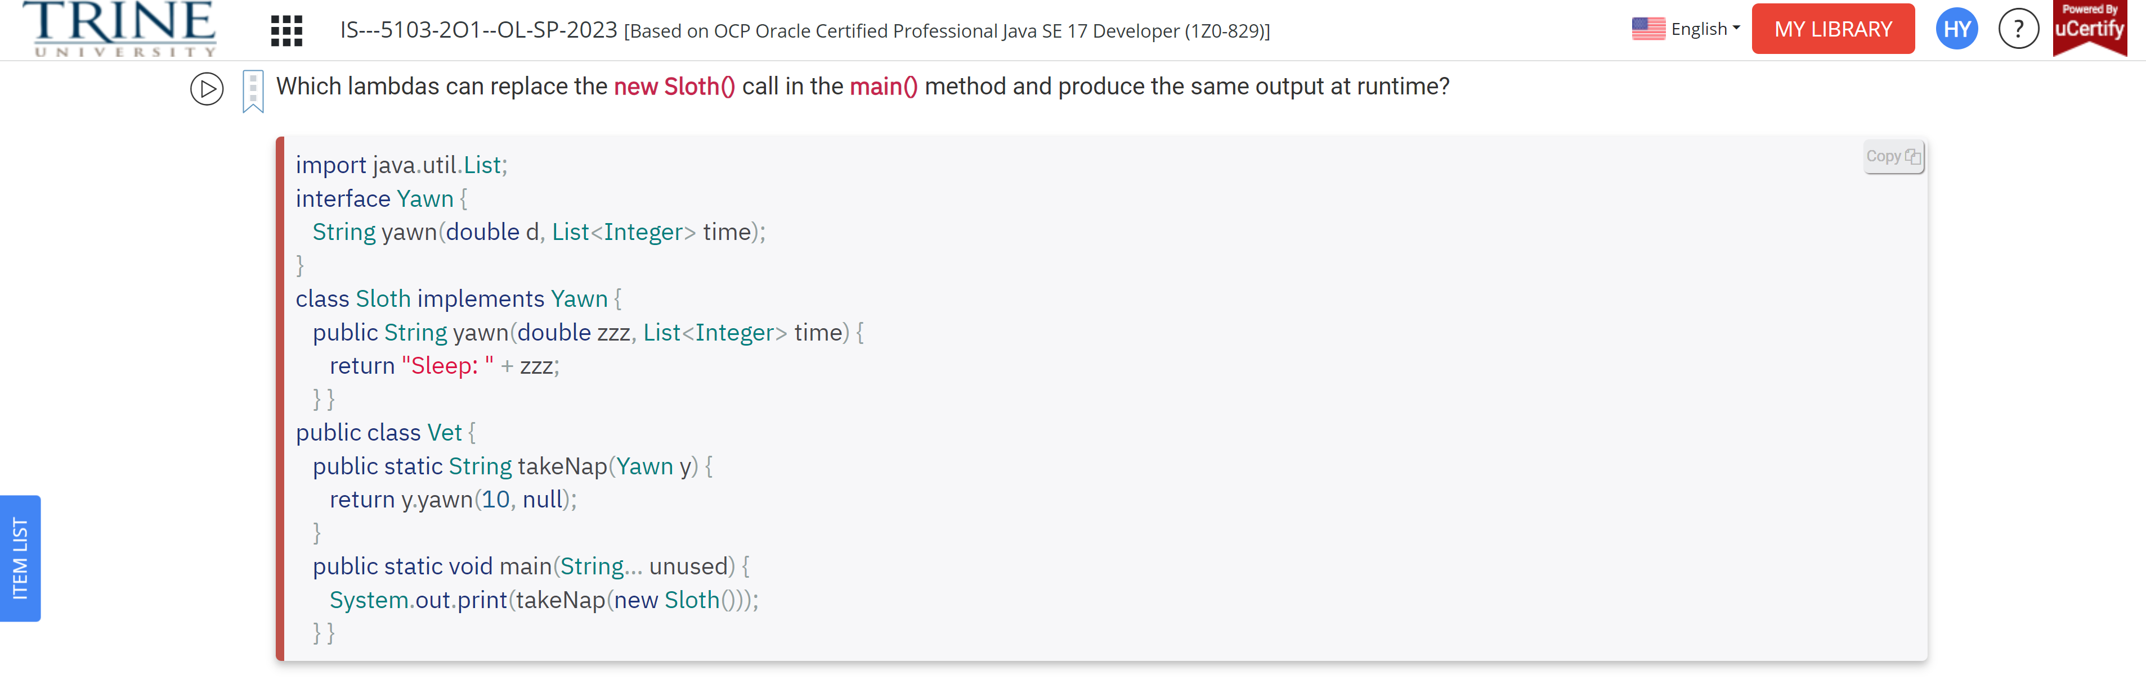

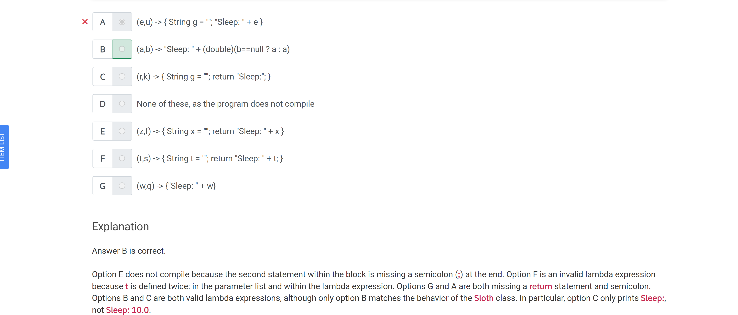

Which of the following functional interfaces contain an abstract method …

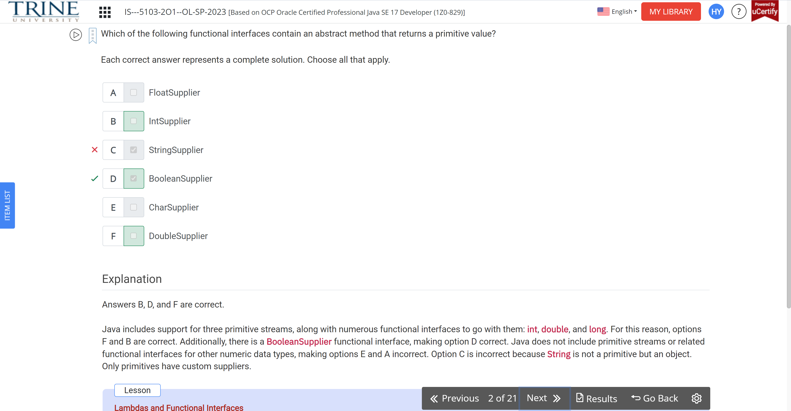

Which lambda can replace the MySecret class to return the same value?

Interface Secret…

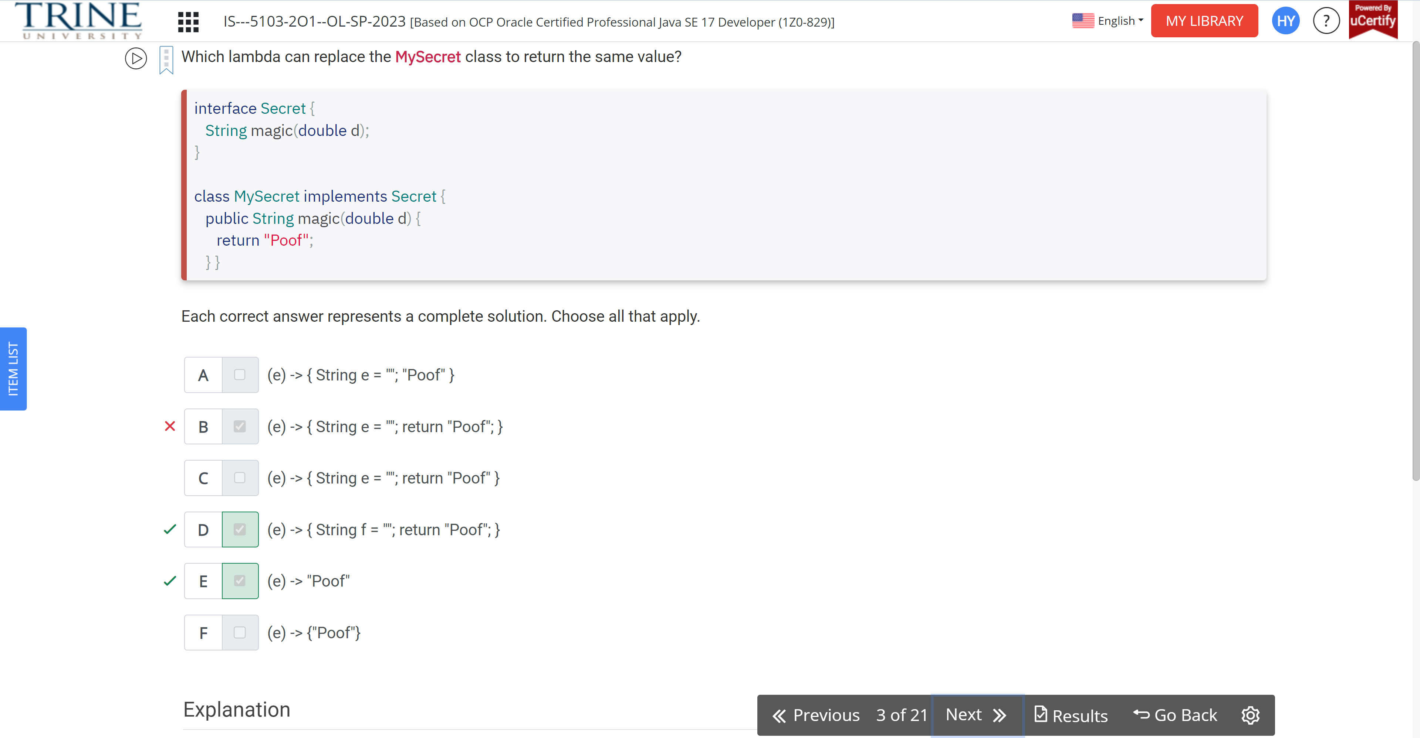

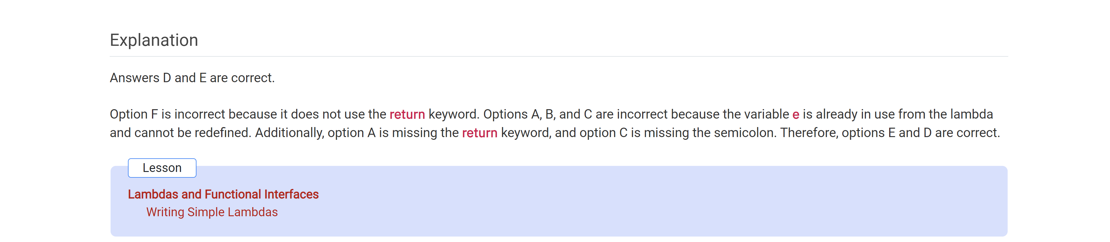

Which of the following can be inserted without causing a compilation error

Public void remove…

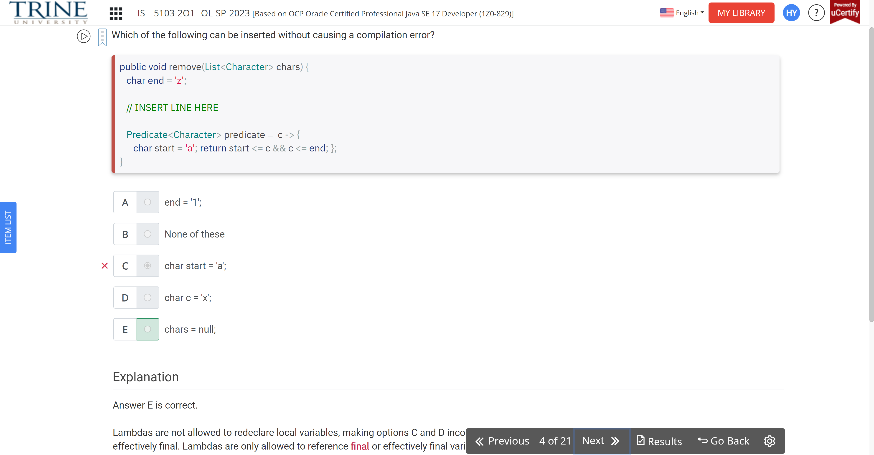

Which is true of the following code?

Int length = 3;

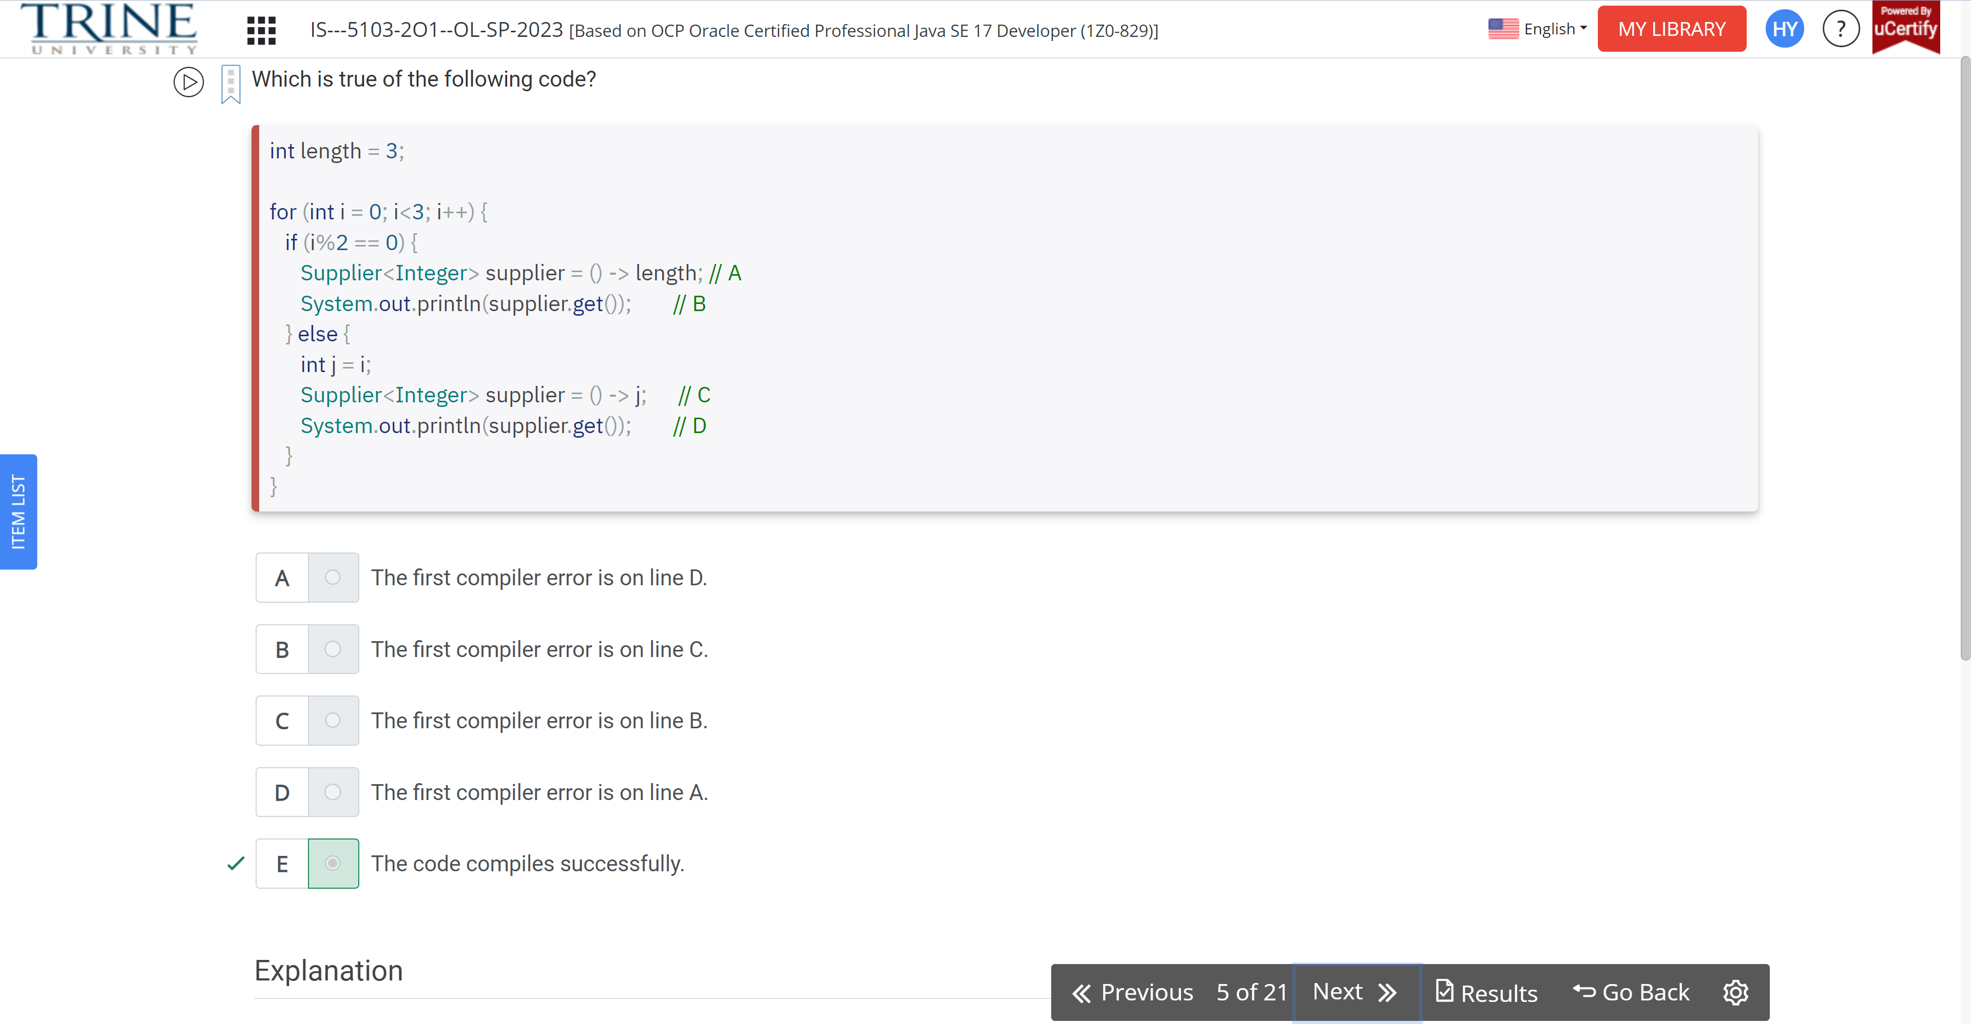

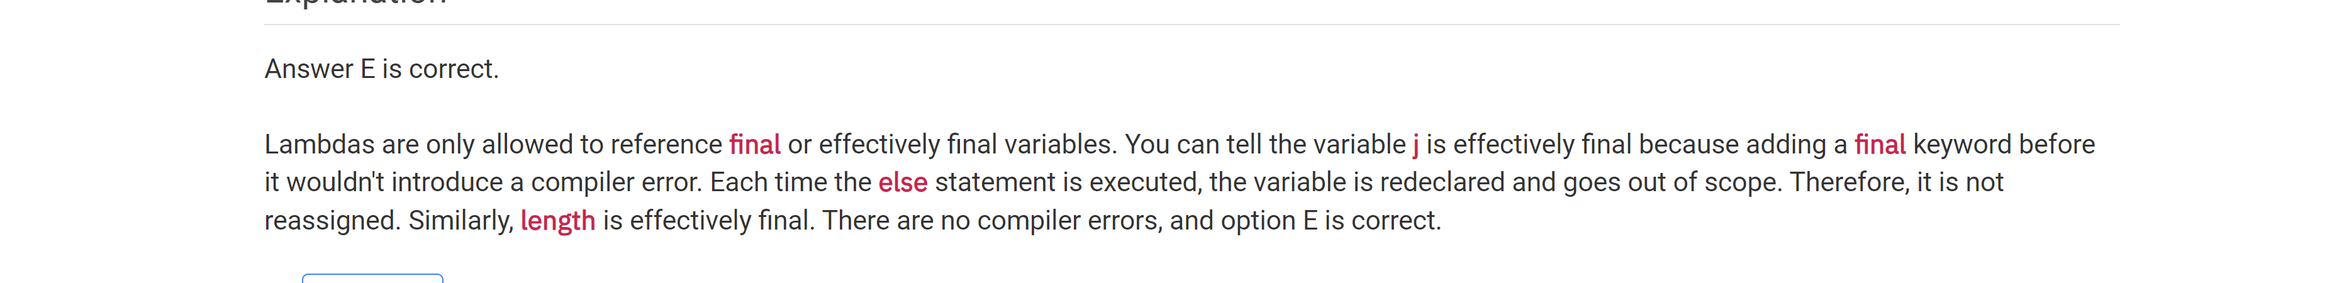

Which statements about functional interfaces are true?

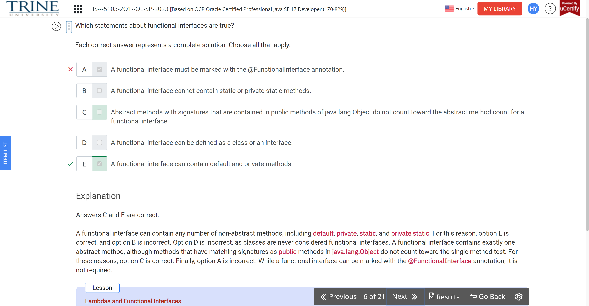

Which of the following are valid functional interfaces?

Public interface Transport…

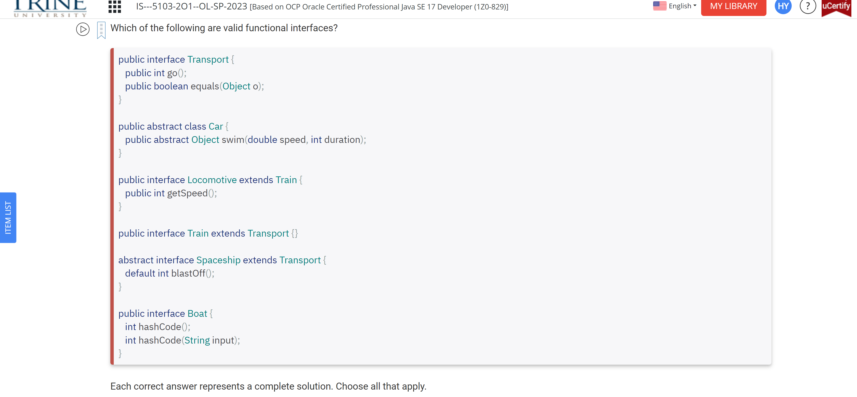

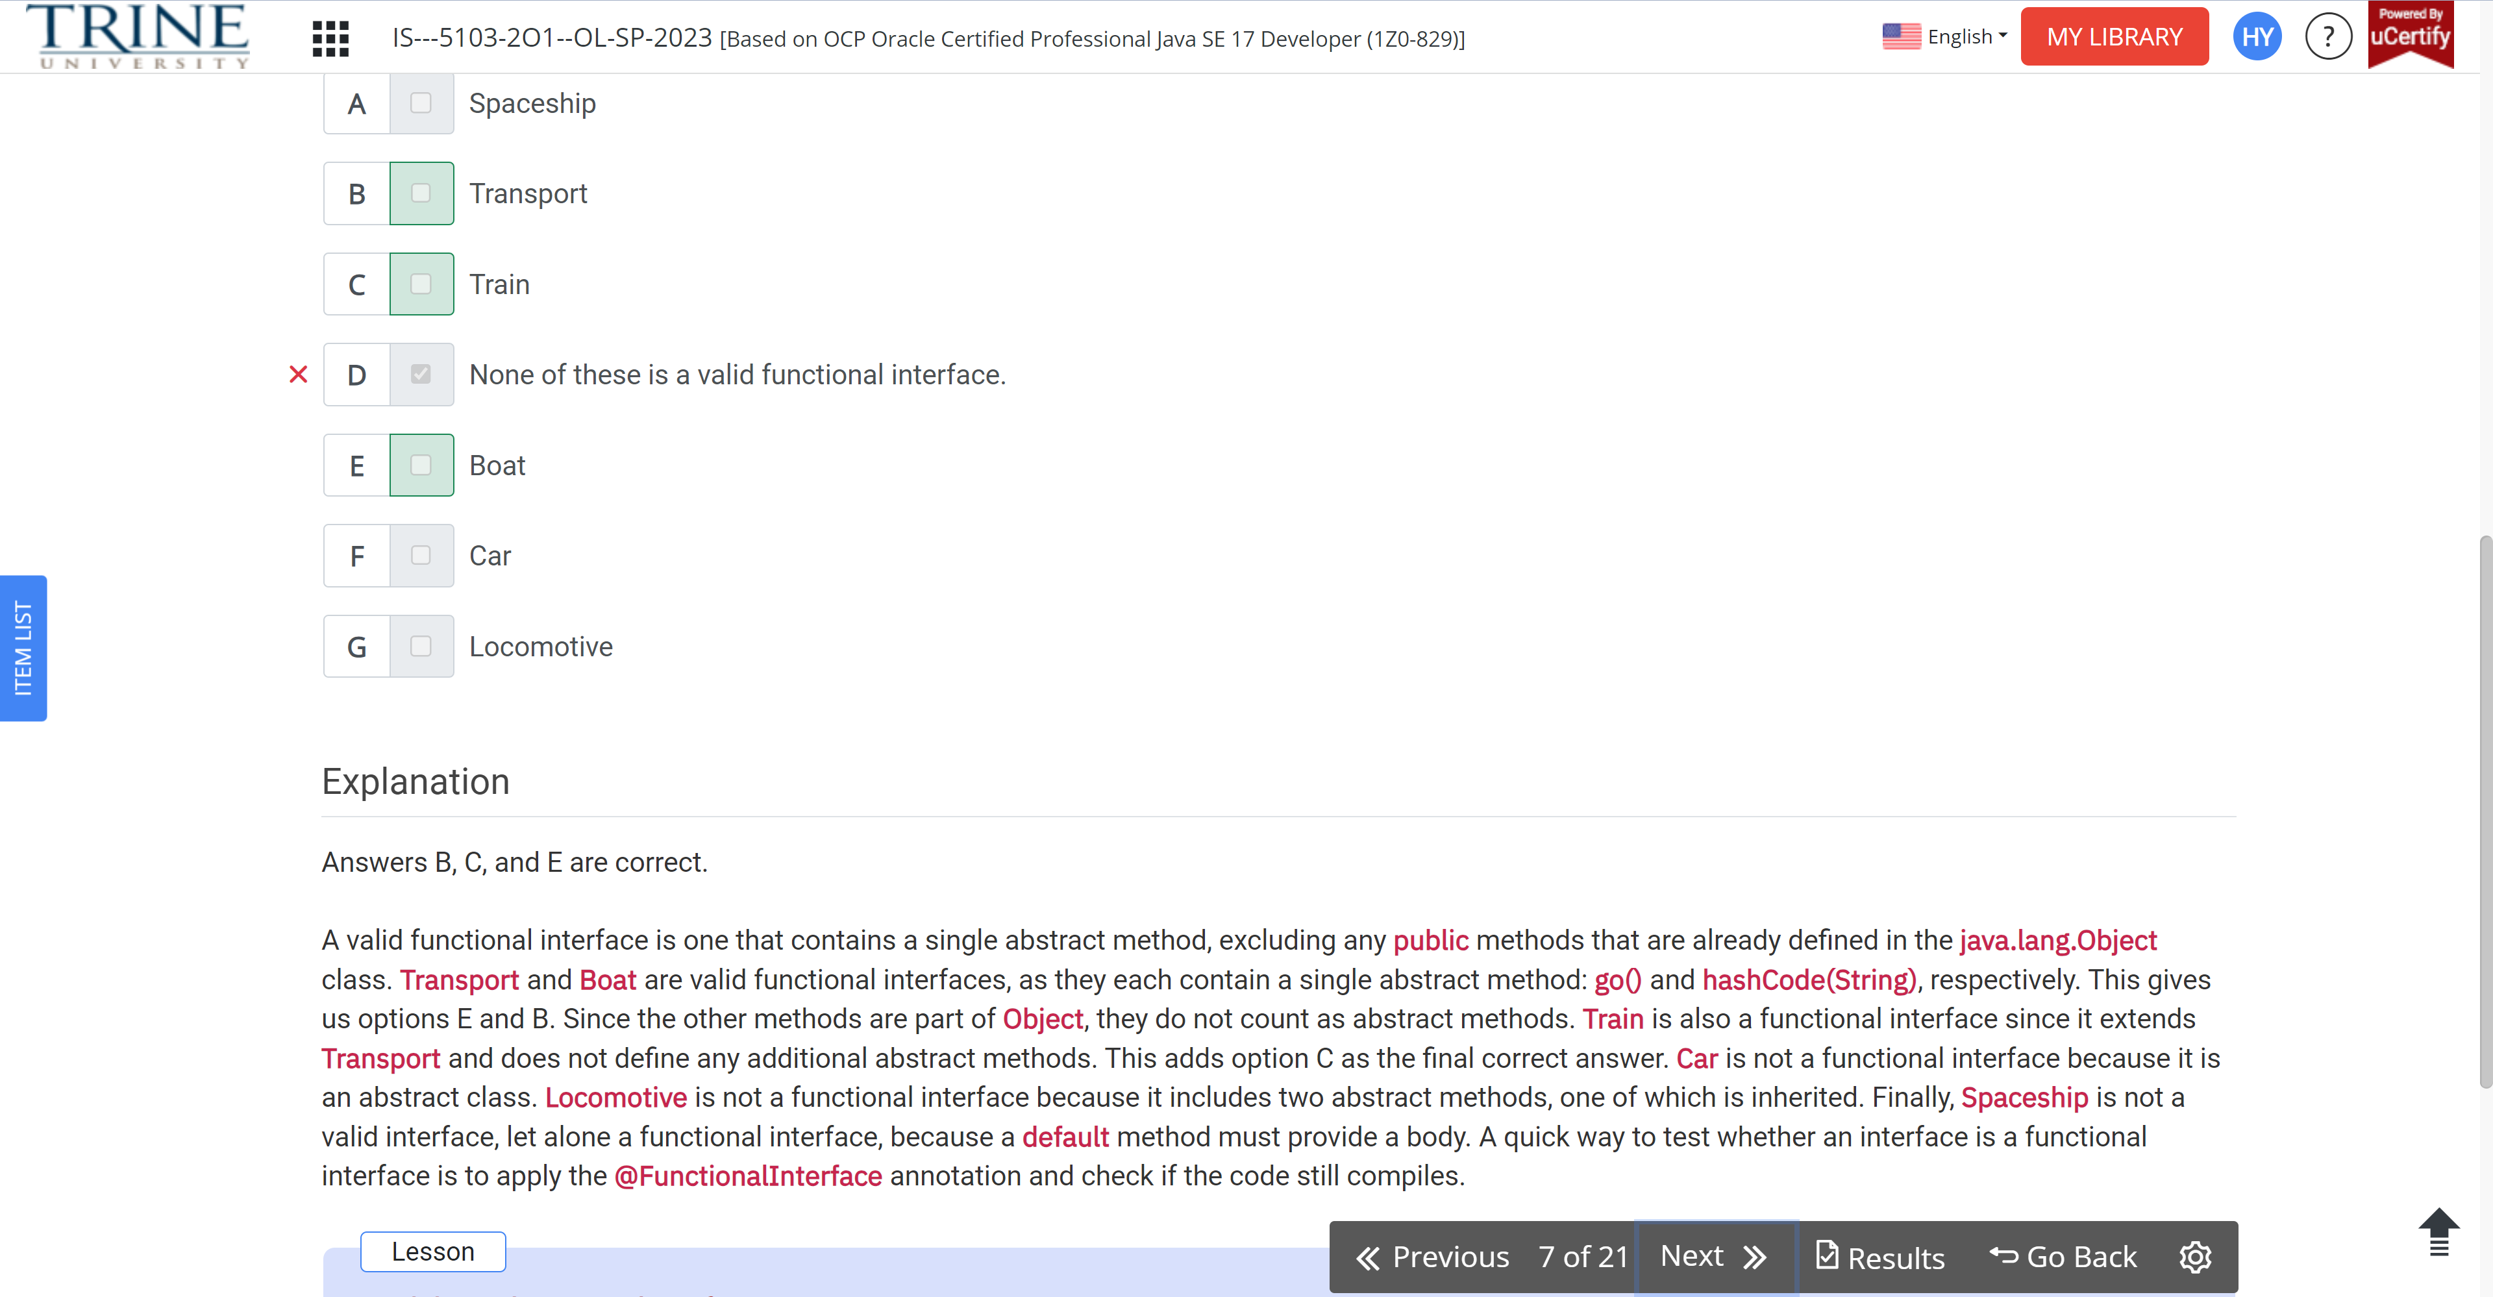

Which of the following is equivalent to this code?

UnaryOperator<Integer> u = x -> x\*x;

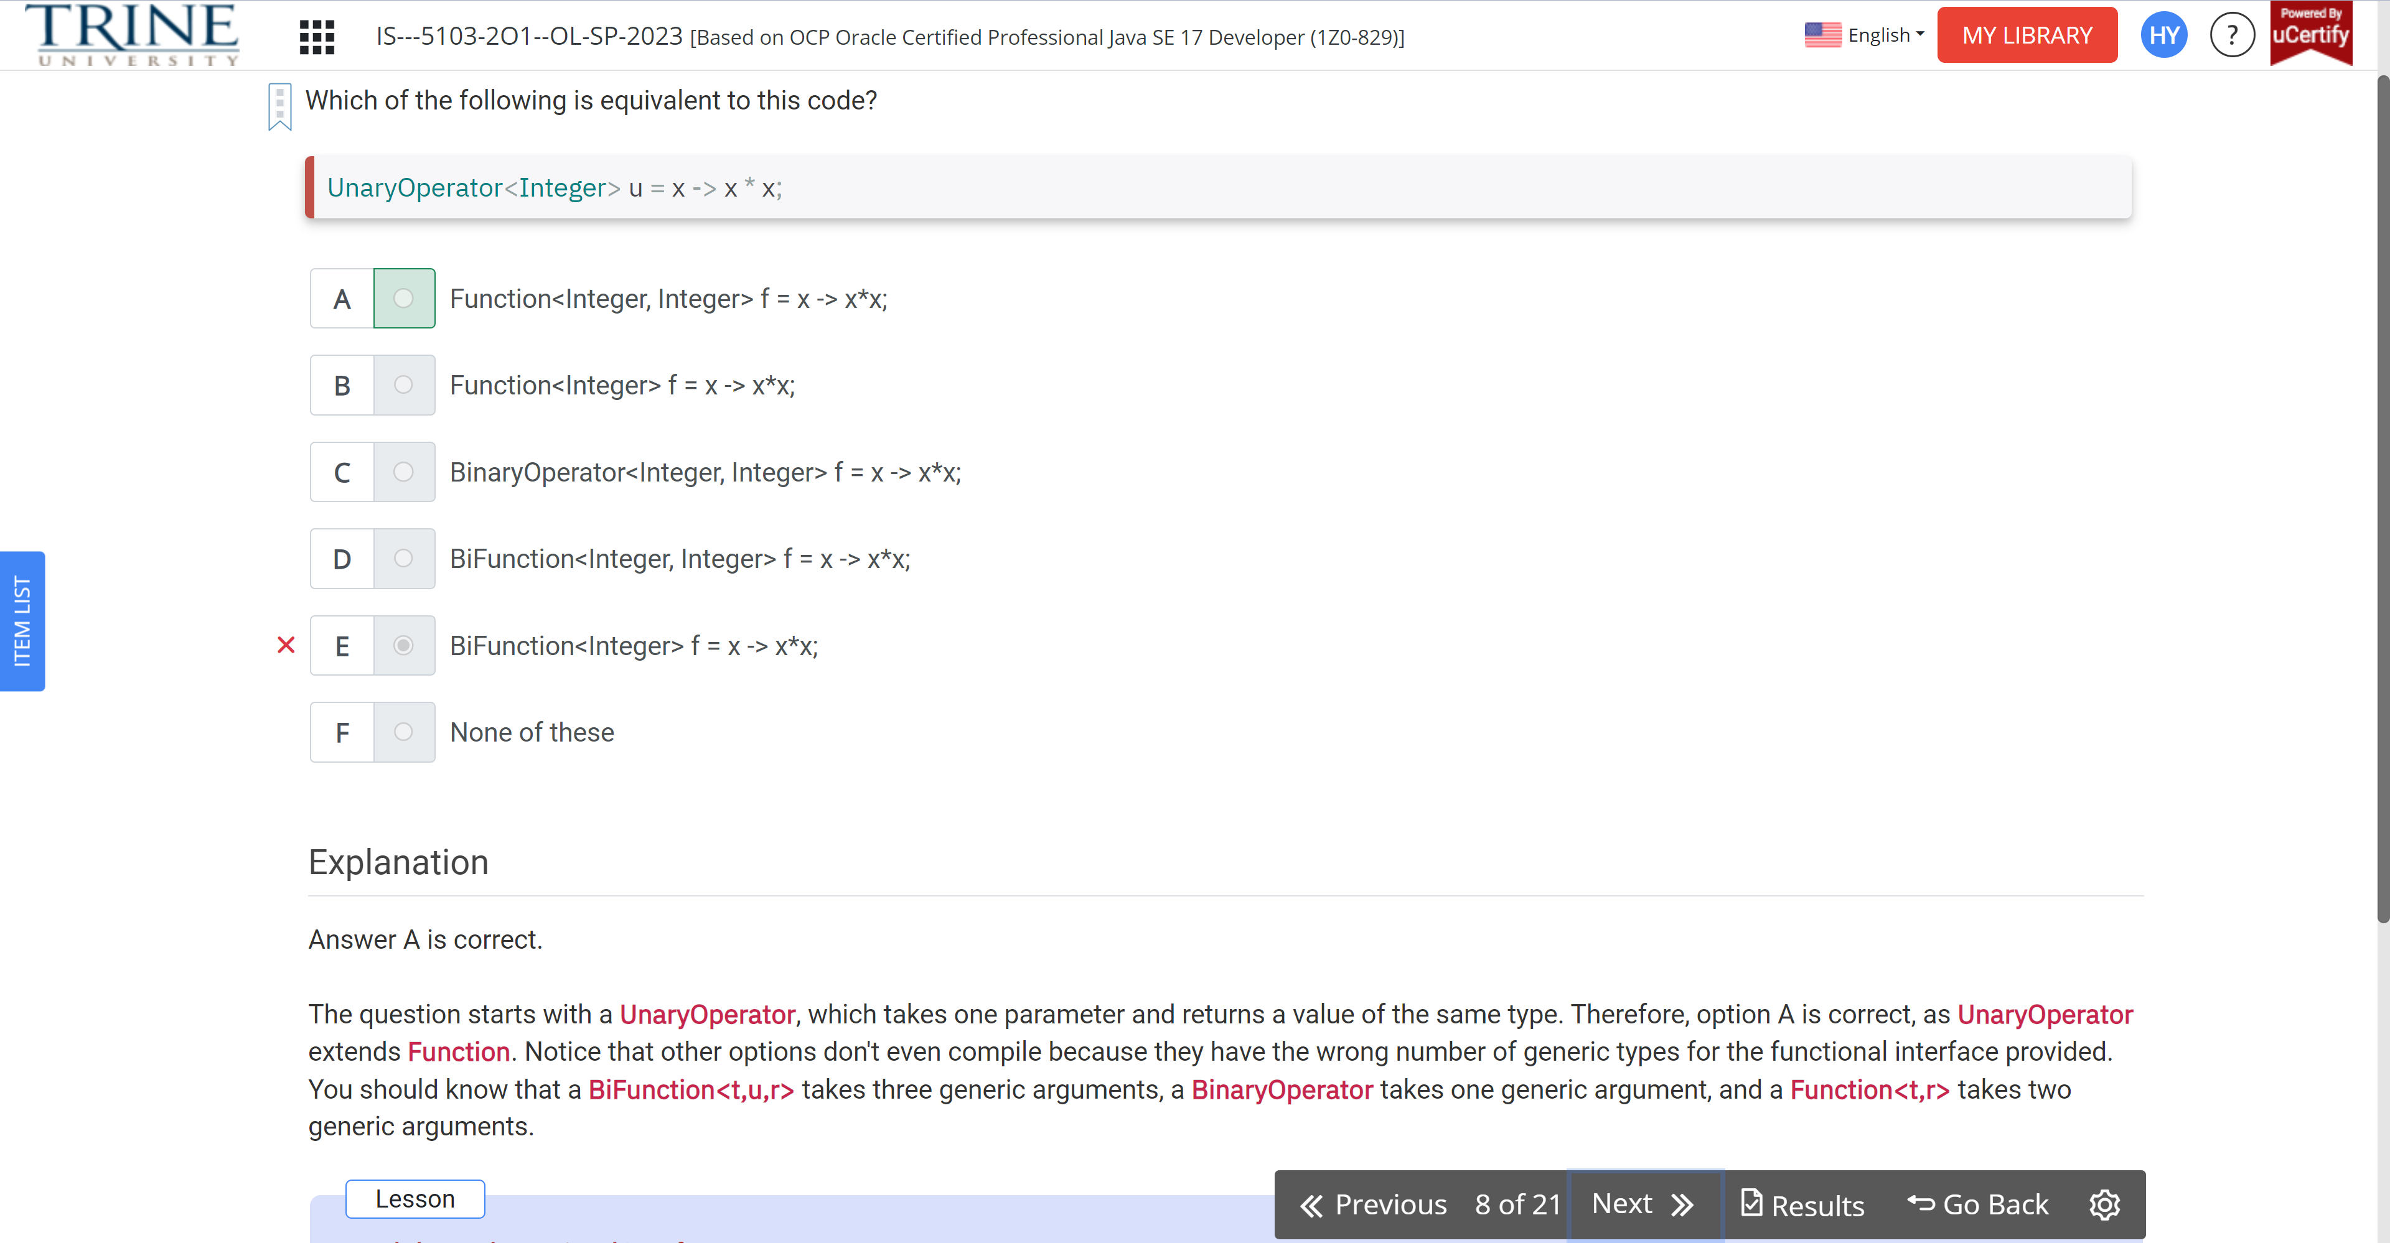

Which functional interfaces complete the following code? For line 2, ..

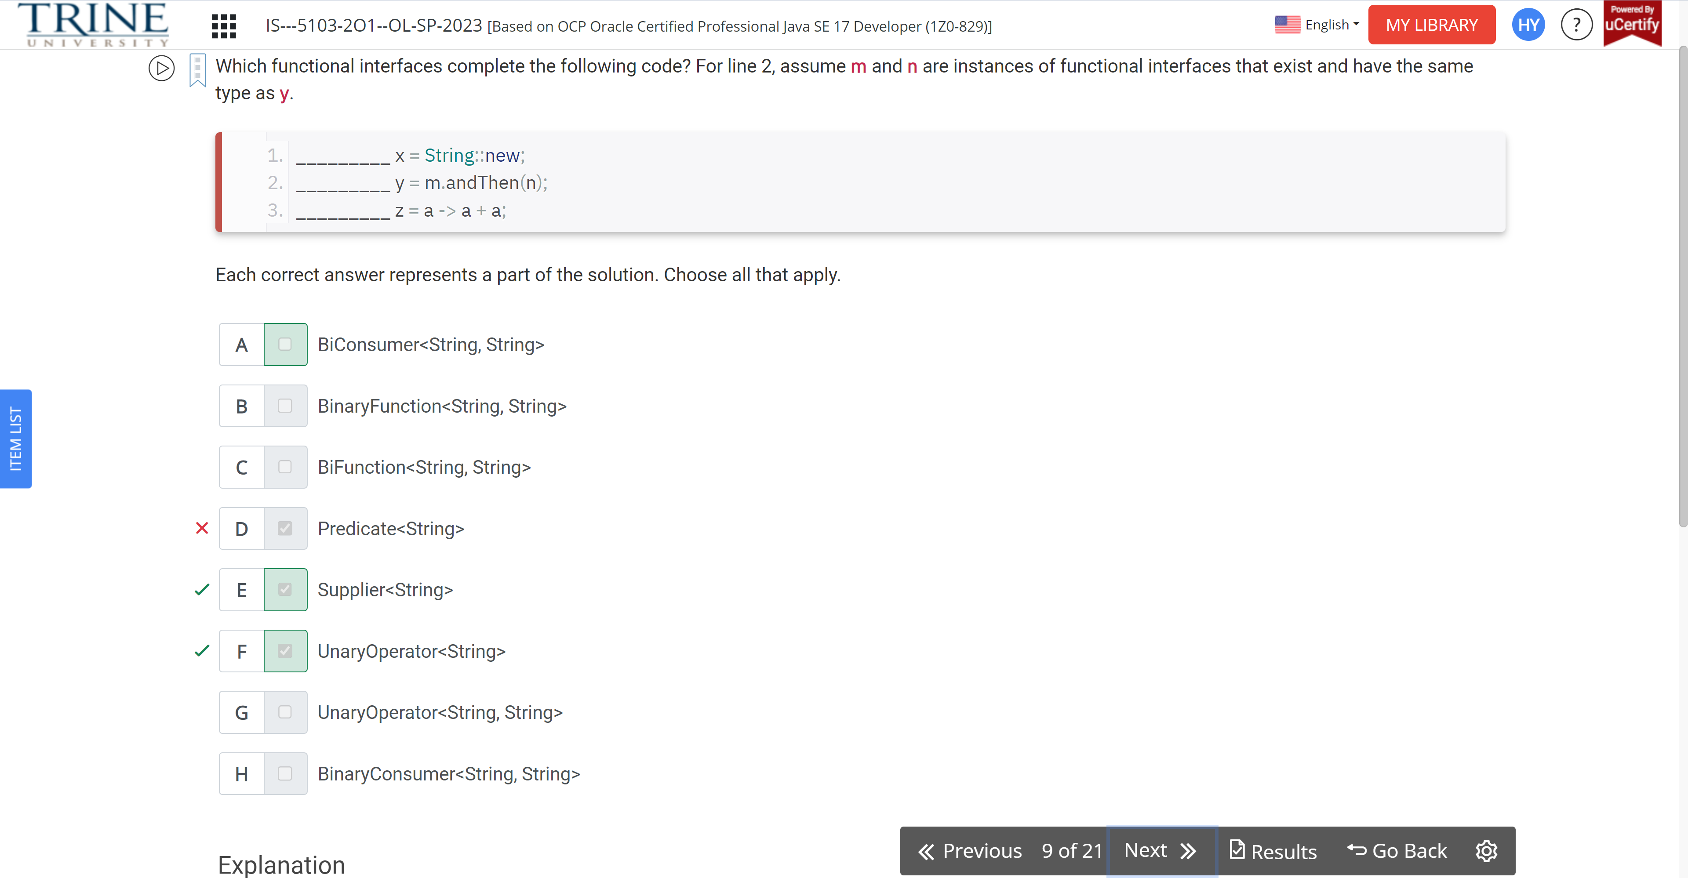

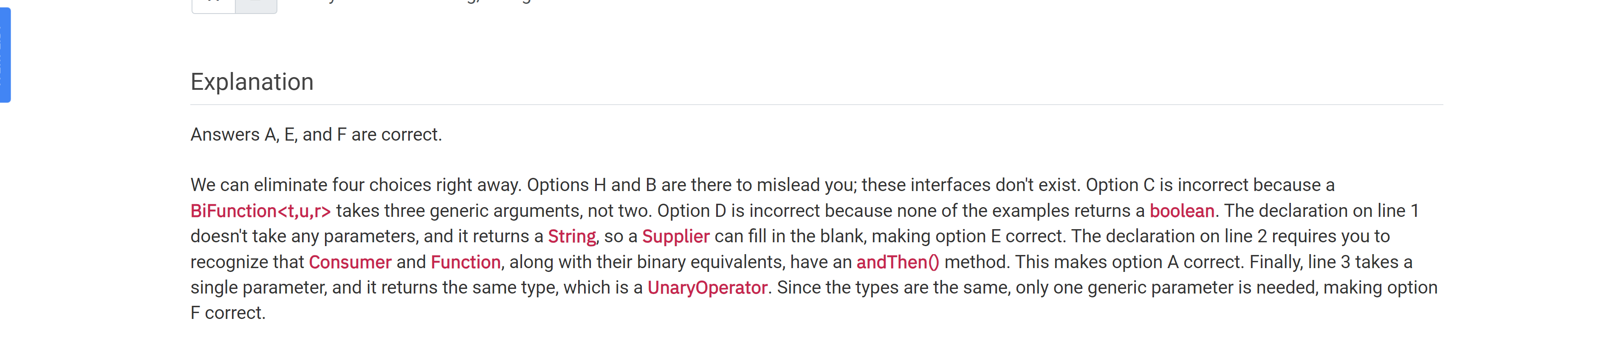

Which of these can fill in the blank and have the code run without error?

Set<?> set = ..

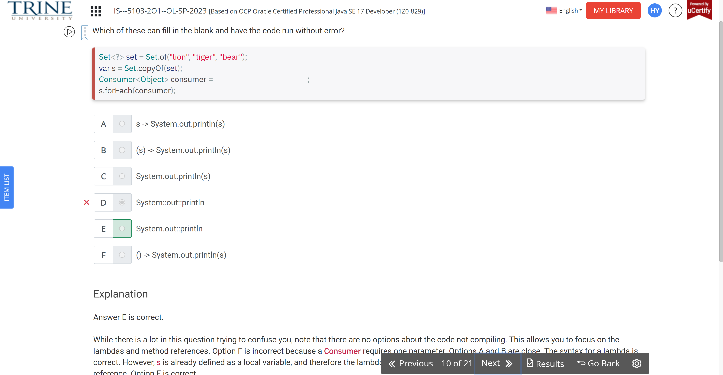

What is the result of the following code?

Interface Climb…

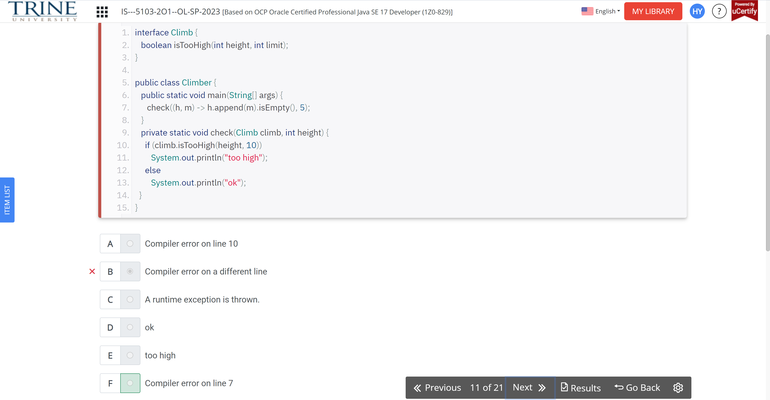

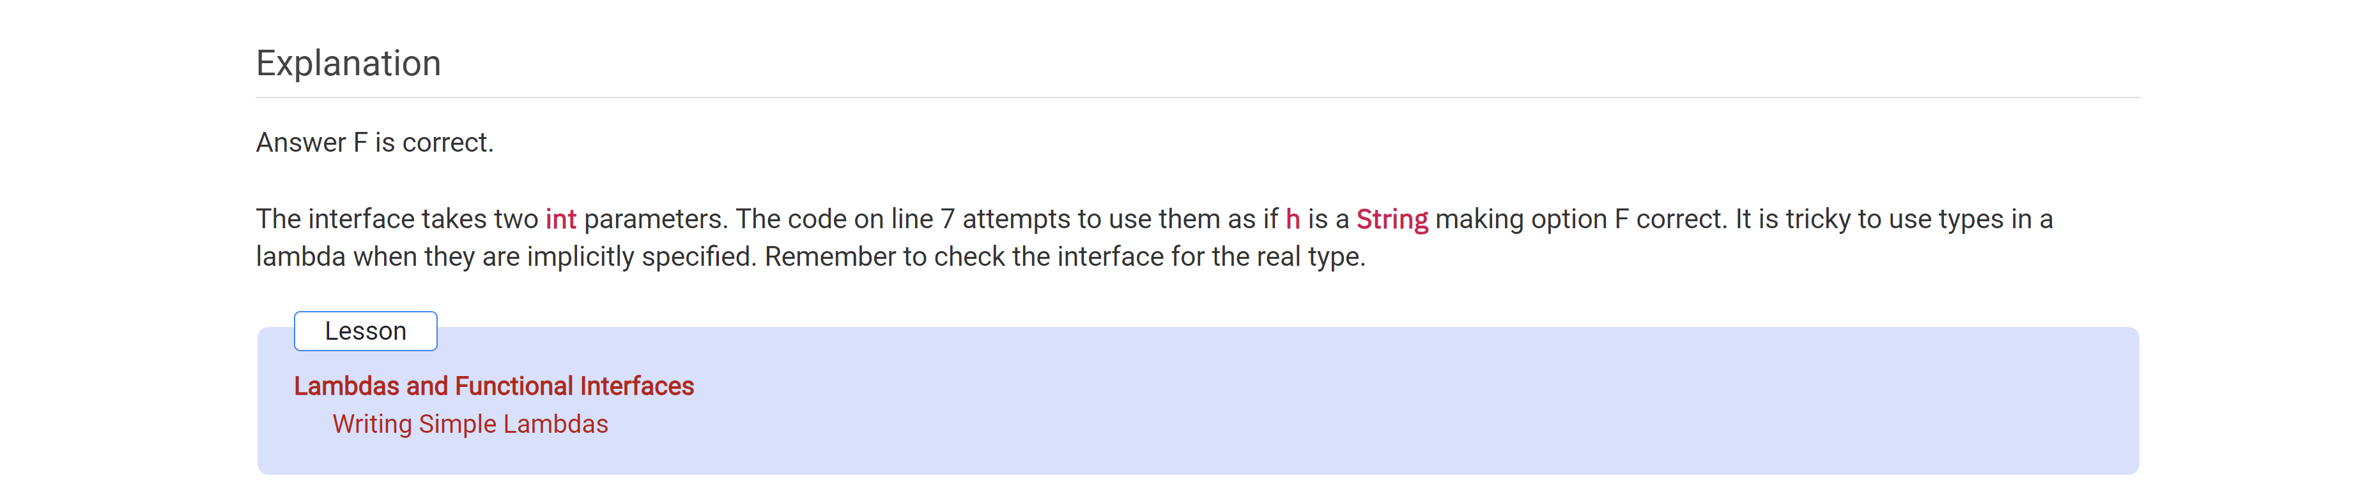

What is the result of running the following class?

Public class Panda…

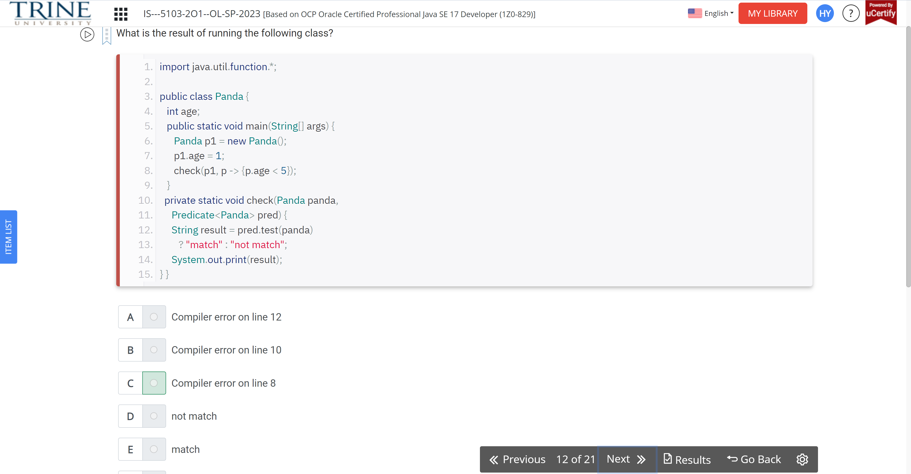

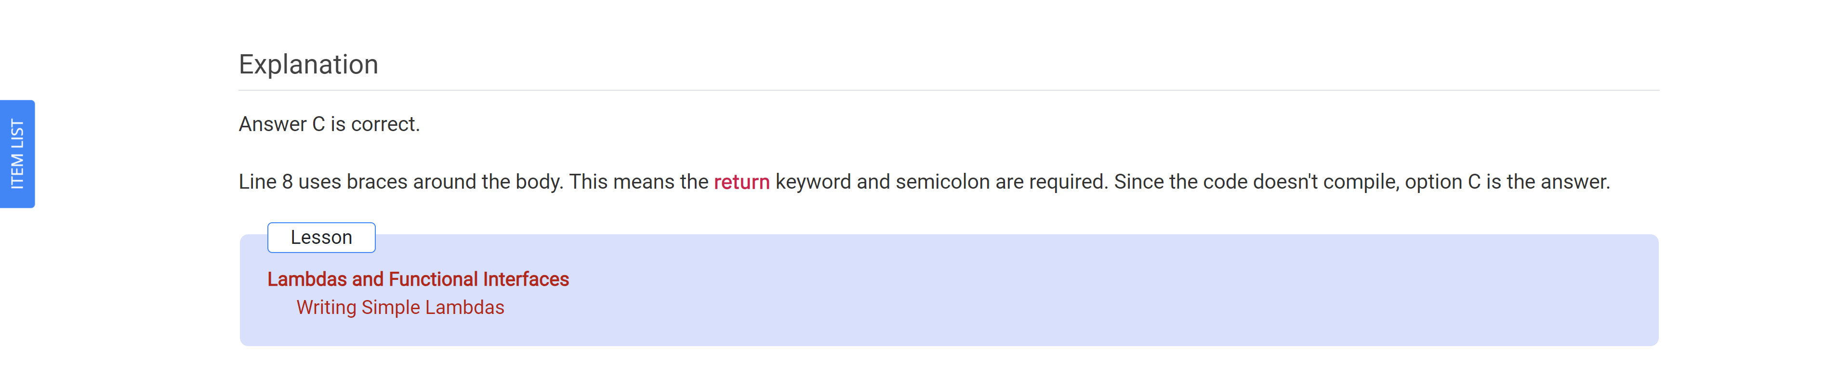

Which lambda expression, when entered into the blank line in the following code, causes the program to print hahaha?

Public class Heyna…

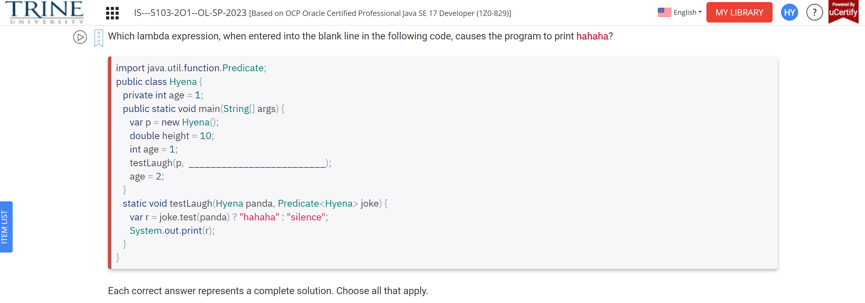

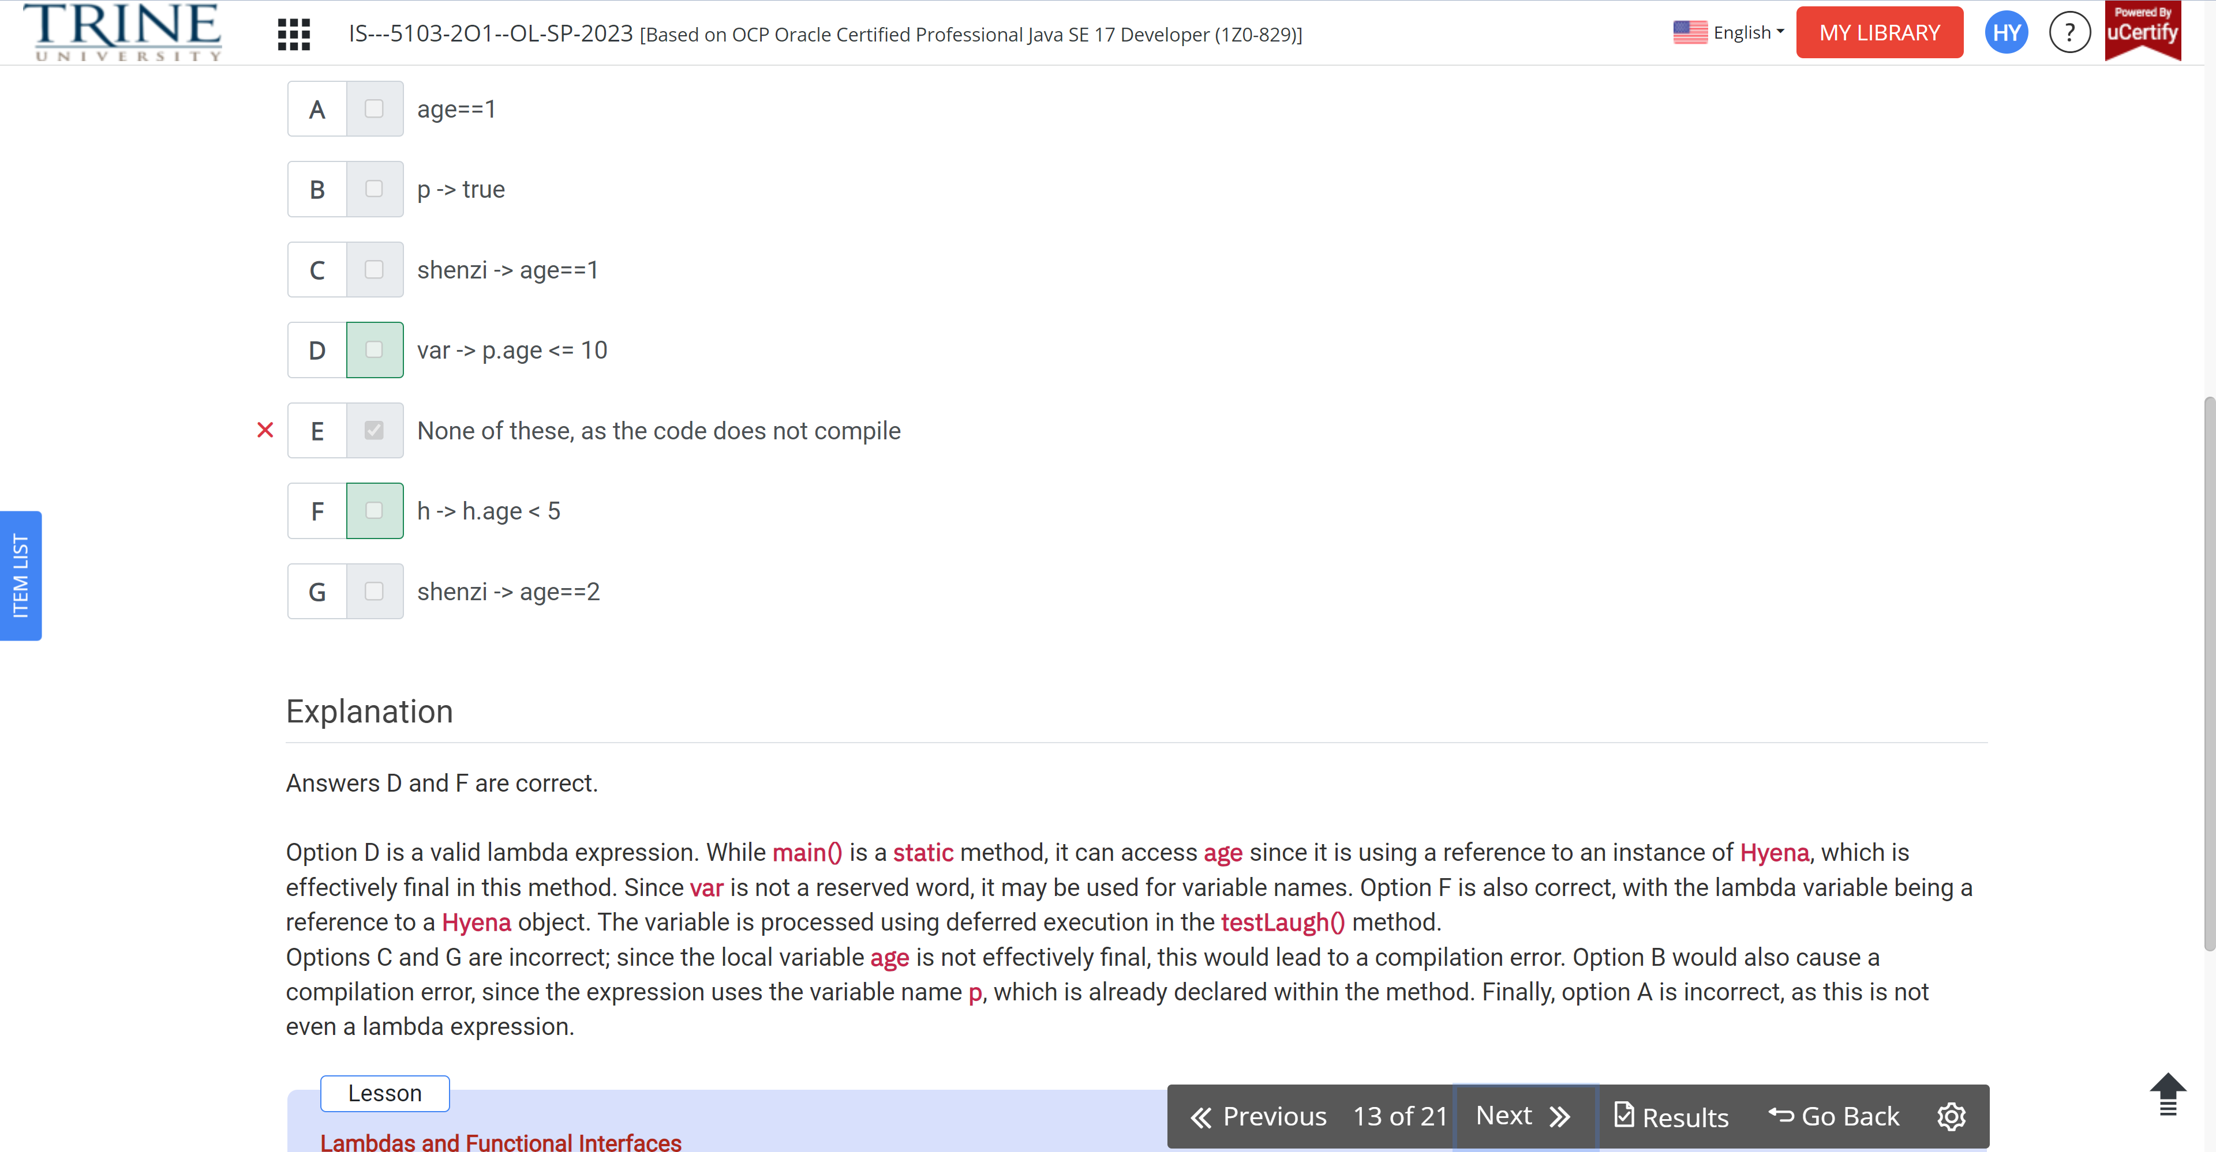

Which of the following lambda expression, can be passed to a function Predicate<String> type?

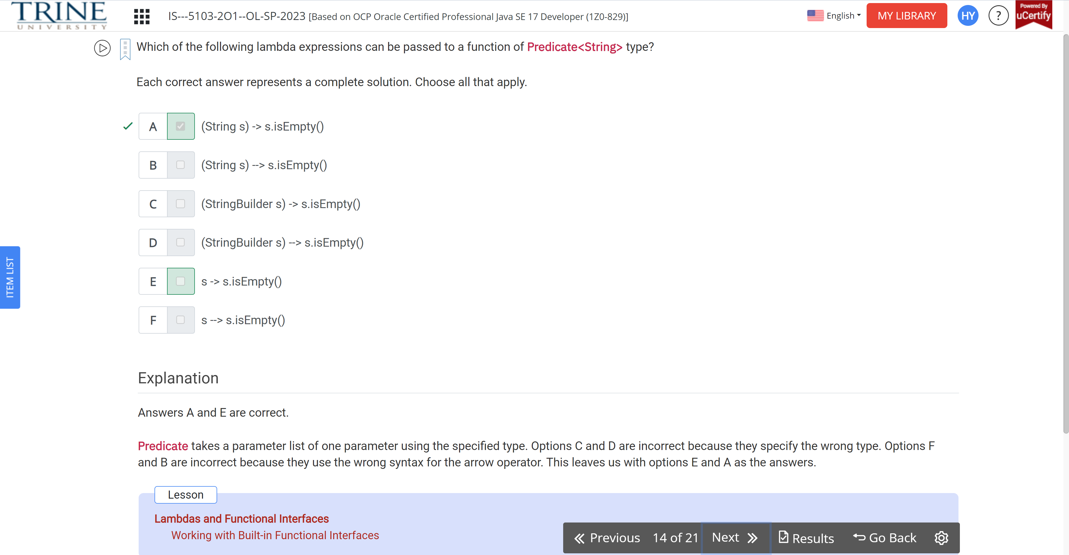

Which of the following are valid lambda expressions?

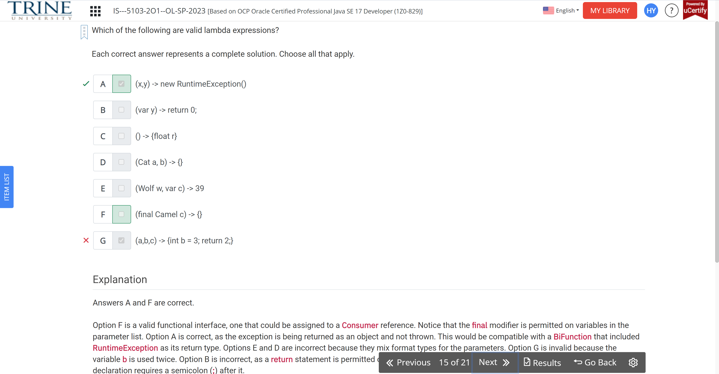Which of these statements is true about the following code?

Public void method()

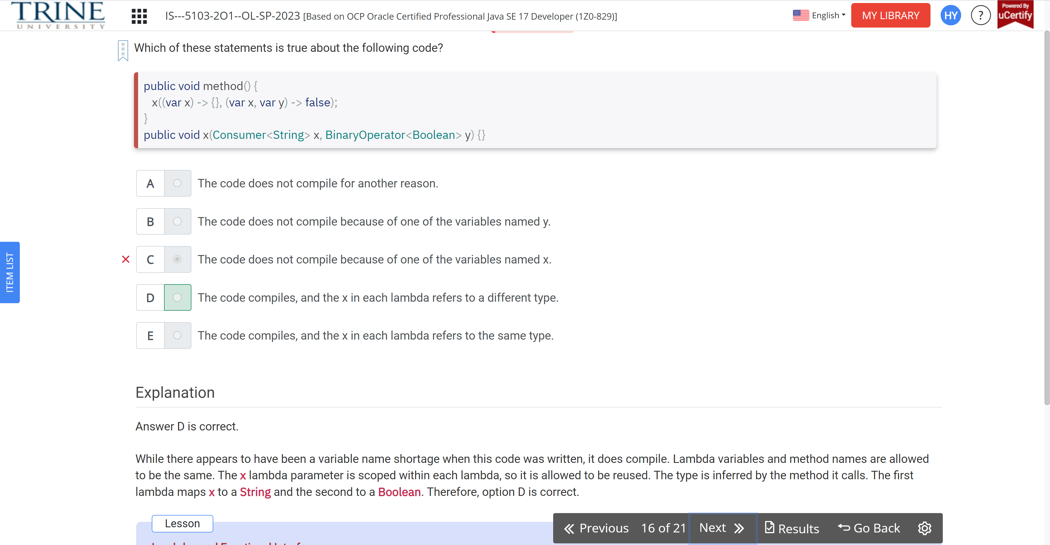

What does the following code output?

Function<integer, integer> s = a -> a + 4;

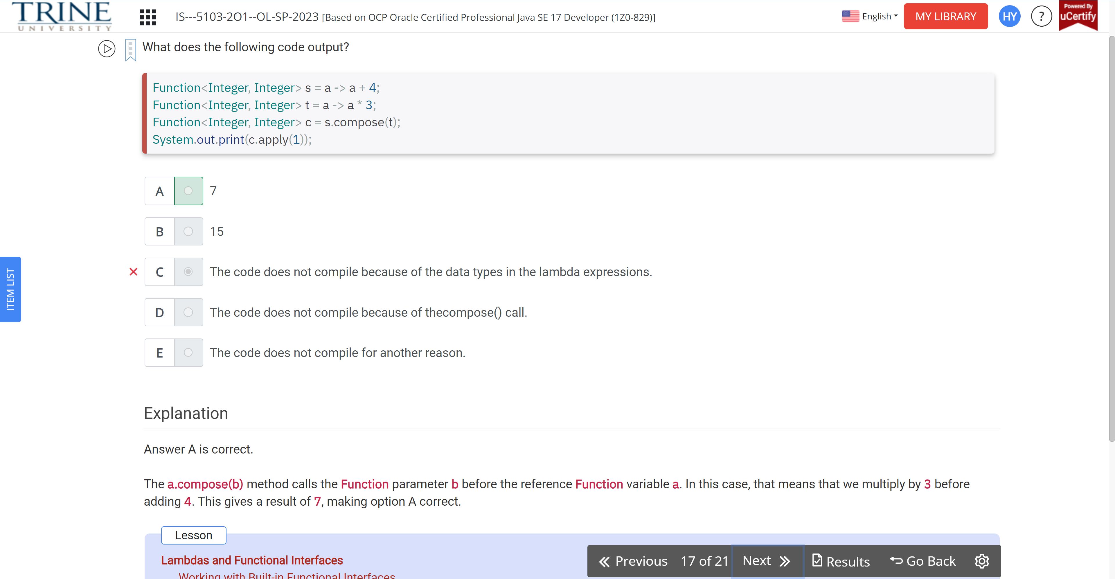

Which of the following can be inserted without causing a compilation error?

Public void remove…

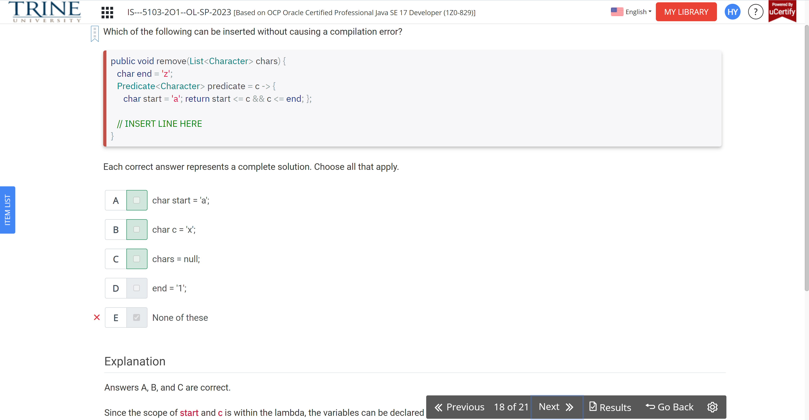

What is the result of the following class?

Public class Panda.. int age

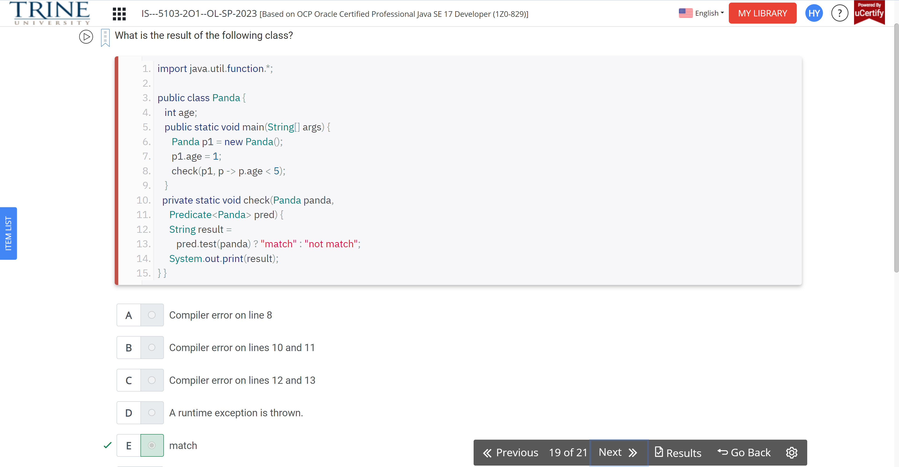

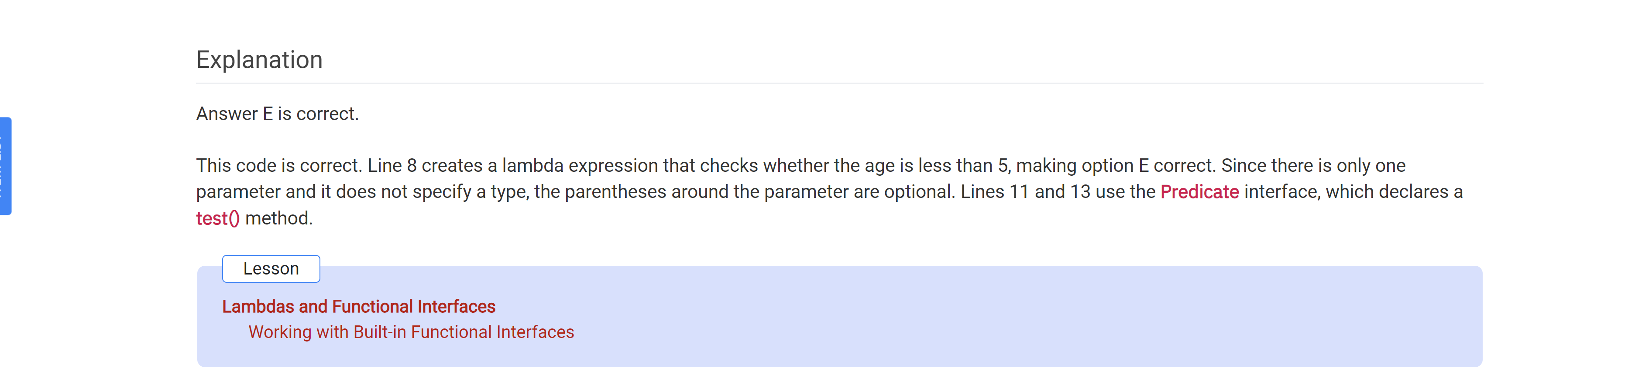

How many times is true printed out by this code?

Public class Fantasy…

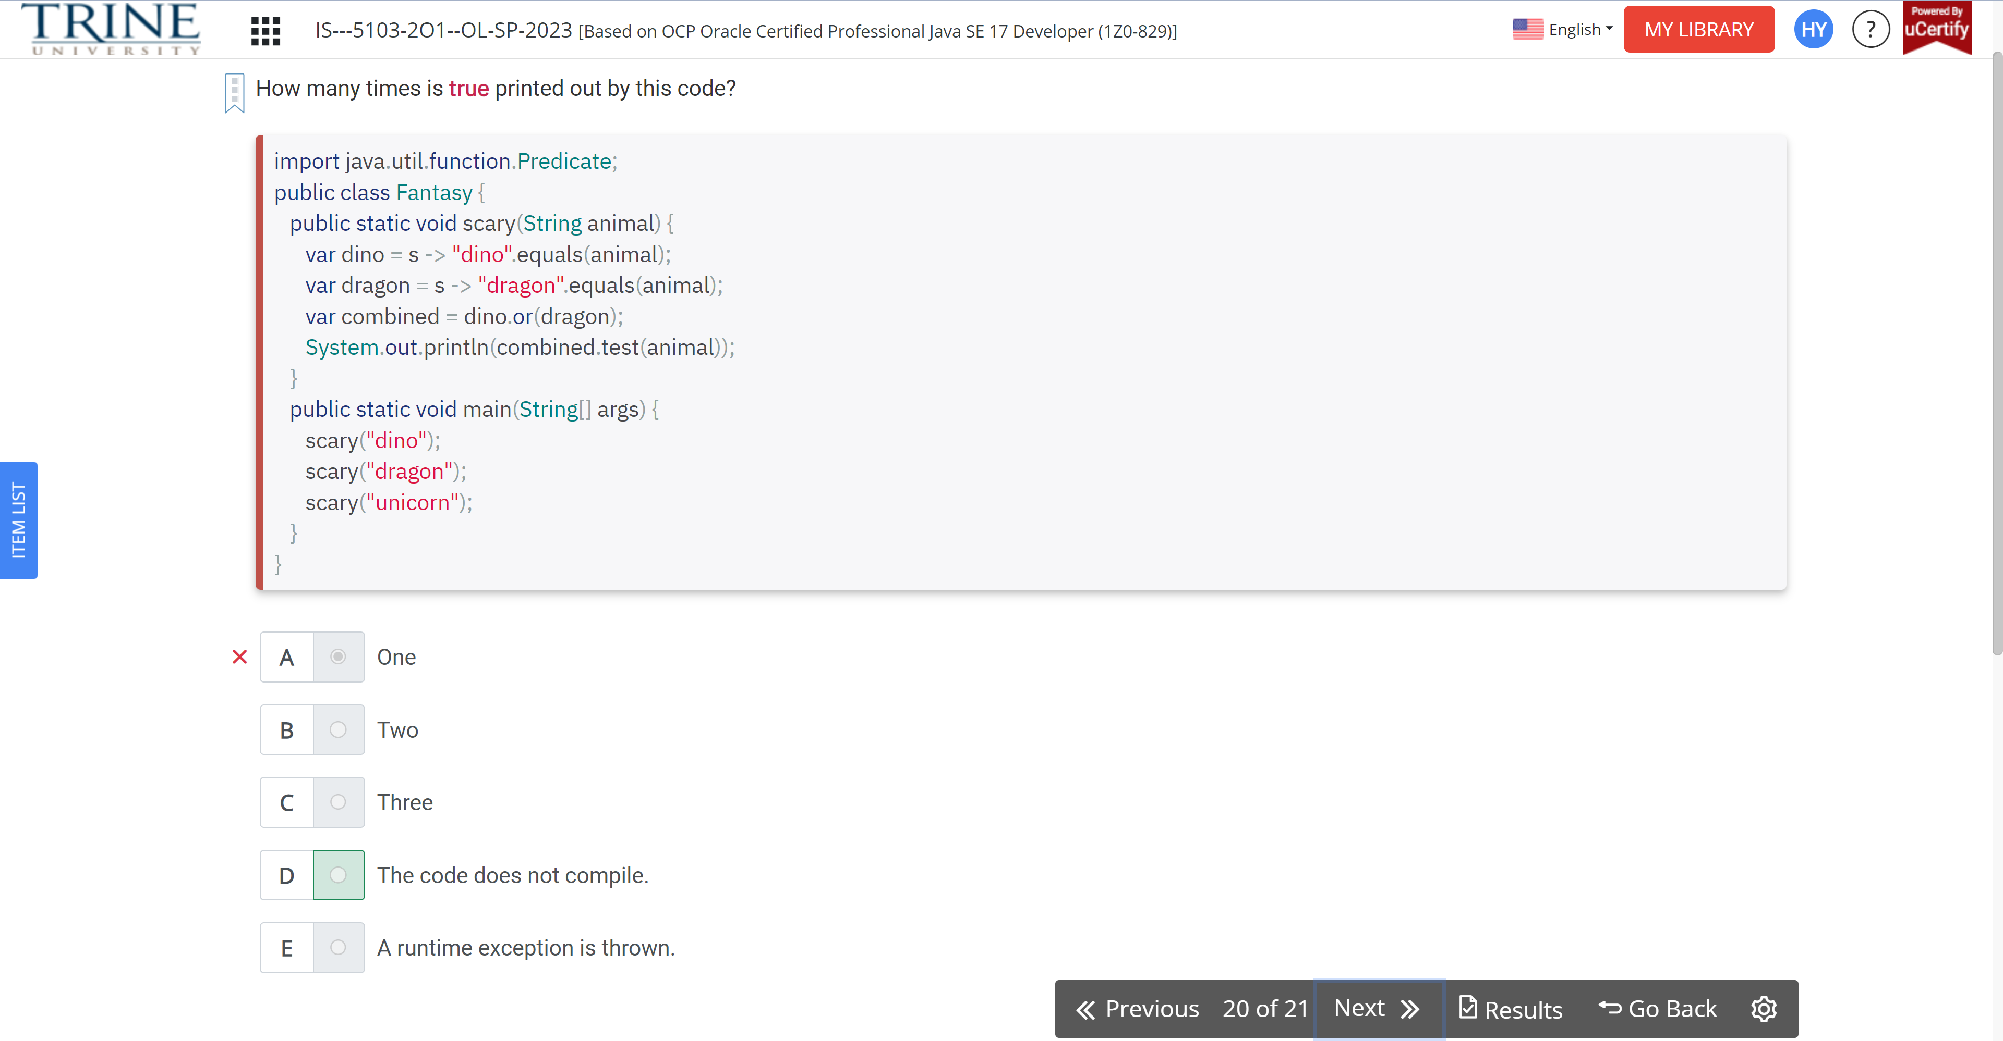

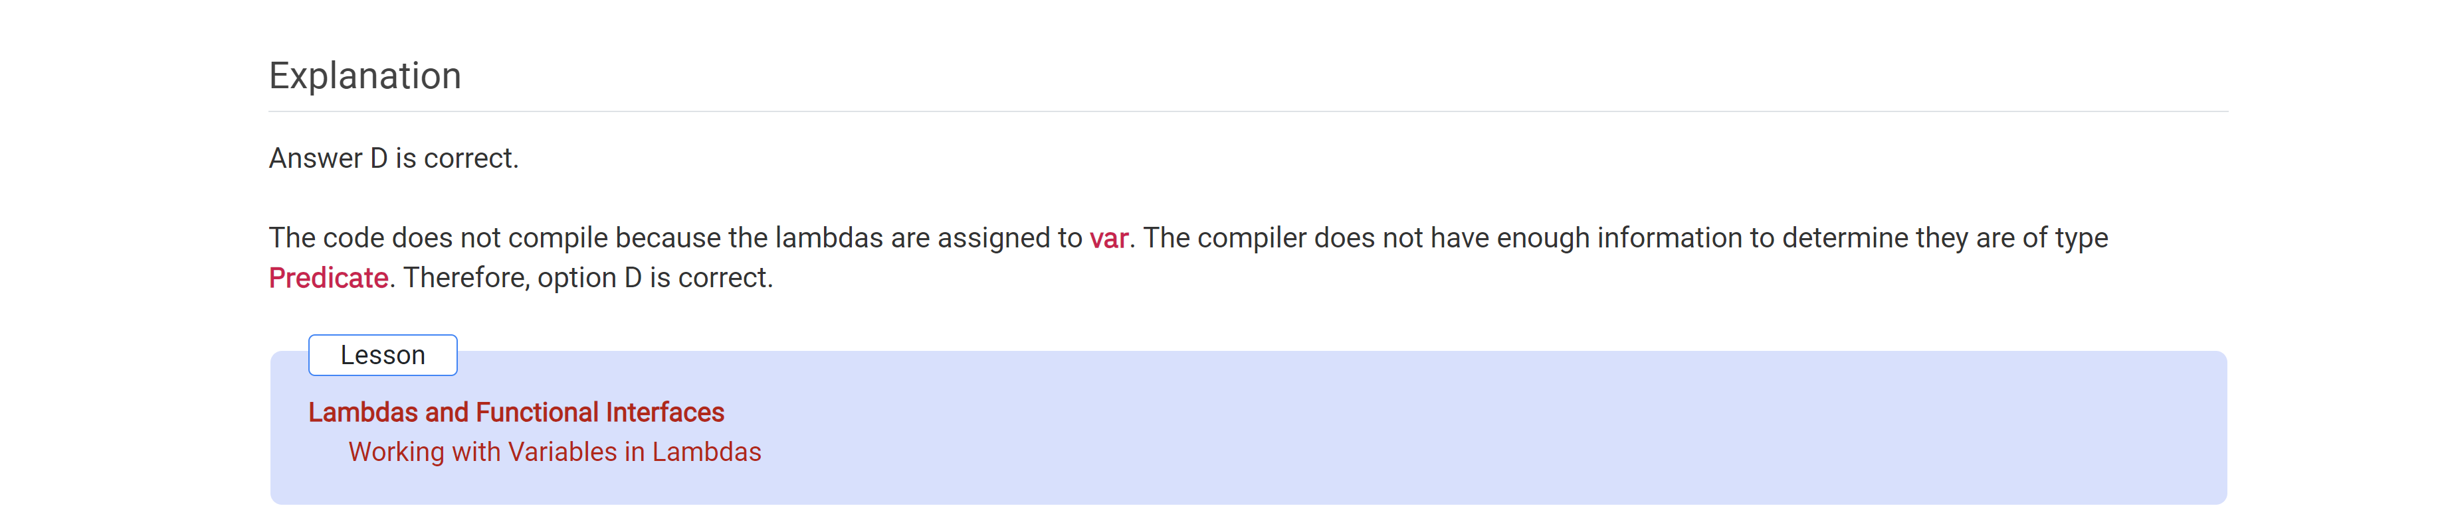

Which statements are true?

